AATC_Server_002
Introduction
The module is the main module used by the server component of the system. The module contains the classes used to serve the different clients. The classes keep obtaining commands from the socket and executing the method relevant to this command. Each type of client has a seperate class , containing the methods for that client. The server starter module as well as the Hedabot module import classes from this module and create a process in which the main loop of the class runs.

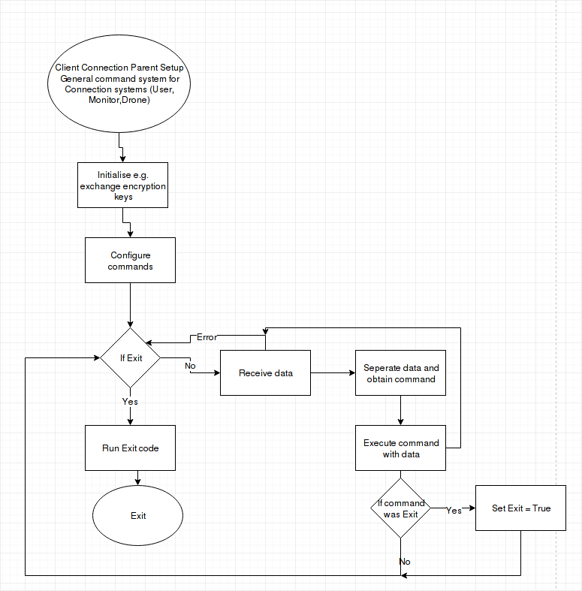

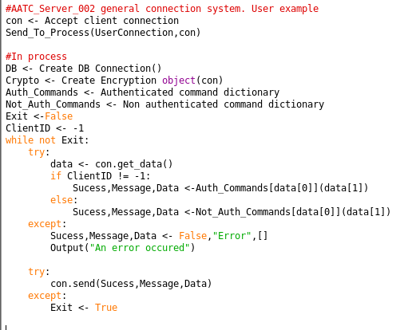

Import
The module imports 12 other modules. Codecs is required to convert the strings to bytestrings and back for use with the socket module. Ast is required to convert these strings back into python literals ( lists , integers, floats, tuples etc). Socket is required to communicate with the clients and recvall is used in conjunction with sockets to allow the program to receive values greater than the buffer length. The random module is used to generate the offsets for the flight waypoints and time is used for various time keeping options and checking when flights should be scheulded.
The AATC_Astar module is used to find paths across the graph of the volume served by the server as well as dealing with the nodes. The AATC_DB module is required to access the database. AATC_Crypto is used to encrypt the communication between the server and the client. The AATC_Config module is used to load constants for the server. AATC_Weather is used to interface with the OWM system to better predict the flight time. AATC_Coordinate is required for various components such as coordinate objects as well as calculating distances.

ClientConnection

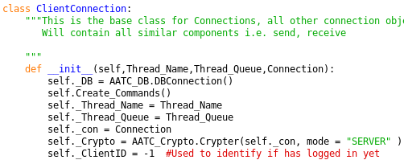

The ClientConnection object is the base class used to merge frequently used features between the different client types such as send, receive, exit and run the main loop. The program takes the arguments Thread_Name, Thread_Queue and connection. The Thread_Name is the name given to this progress by the process spawner in AATC_Server_Starter. Thread_Queue is a command queue which passes commands from the higher levels in AATC_Server_Starter to the client connection passing instructions such as to Exit. Connection is a socket connection to the client.
A connection to the database is created and the passed arguments are stored as attributes. The command dictionaries are created.The Crypto connection is created using the connection object and is set to the server mode as this is the server side of the exchange system. The ClientID, which keeps track of the ID for the current client is set to -1 ( the default for a non authenticated client).

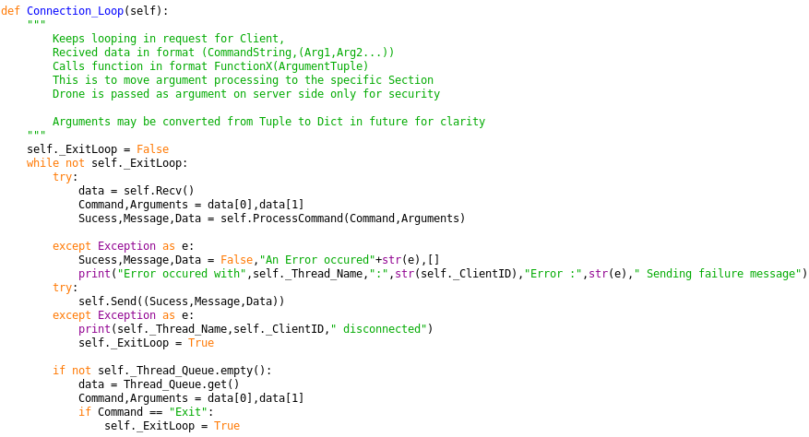
The Connection loop method keeps the program looping continously until it ExitLoop is set to True. The program then attempts to obtain data from the client using the Recv method, which returns a tuple of (“Command”,(Arguments….)) , the arguments and command are split and used as parameters for the ProcessCommand method which executes the relevant command and returns the Sucess,Message and Data variables. Should an exception occur it will be caught in the try/except statements , in this case the success, message and data variables are set to false, “Error message” and empty list respectively and an error message is displayed.
The program will then attempt to send the Sucess, Message and Data variables using the Send method to the client , should an exception occur it will be caught , disconnection message displayed and the loop set to exit ( if the sending fails program assumes connection has been terminated , therefore it should exit).
Finally the program checks the Thread_Queue for commands, the command and arguments are obtained and if the command is Exit, the program will exit. When the program exits the database connection will be terminated and the connection will be closed, finally the process will exit.

The Send method is used to send data to the client. The method takes the data which should be sent and converts it into a string, then a byte string and encrypts the result using the Crypto object. The program then sends the result using the connection object.

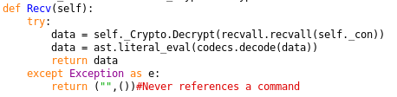
The Recv method is used to receive data from the client. The program attempts to use the recvall.recvall function to obtain the entire message ( greater than the buffer size) and decrypts the result. The decrypted message is then converted to normal string and converted using ast.literaleval into a python literal ( this is safe as it does not execute arbitary code and only converts to python literals). The data is then returned. Should an exception occur the program will return a (“”,()) response as this will cause the command to be unrecognised and therefore nothing will execute and the program may recover from the connection error.

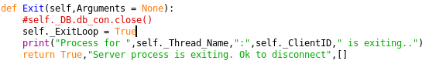
Finally the Exit method is used to terminate the connection between the client and the server. This sets the Loop to exit and returns the confirmation that the server is ok to exit.

UserConnection
The UserConnection class is the class used by the User client type and inherits from ClientConnection. The User may create and remove drones, flights and no fly zones, alter various permissions belong to themselves as well as alter the credentials of their drones, create , remove and modify monitor permissions and many other things. A user may be a human or a different program used to manage the drone.

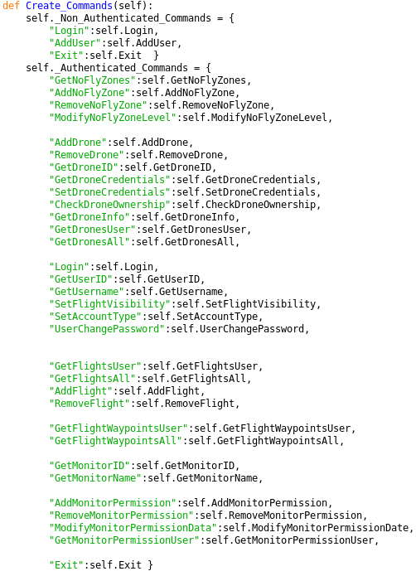
The Create_Commands method is used to setup the command dictionaries for the authenticated and non authenticated users. The first dictionary maps all command words to the relevant functions for users which are signed in while the second serves those users who have not signed in yet with minimal available commands in order to sign in , the segregation preventing users accessing settings when they should not. To add a new command add an entry to the relevant location with “Command”:self.Command function name.

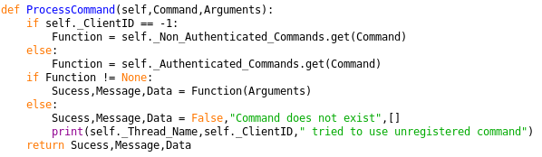
The ProcessCommand method is used to execute the relevant command using the command and arguments provided as arguments. Should the user not yet be signed in the function is extracted from the Non_Authenticated_Commands dictionary , otherwise the authenticated commands dictionary is used. As the get function returns None if the key is not in the dictionary the function will be None if the command does not exist. Therefore the program will execute the function if it is not None and return the message that the command does not exist if it is None. Finally Sucess, Message and data variables obtained from the function or the alternative are returned.

Most of the following functions follow a general rule, deviations and purpose in each will be explained. The method will take one argument called arguments, this may be optional if the method does not require arguments. The program will then extract the variables from the arguments variable , modifying them if need by and storing them in other named variables. The program will then execute one or more commands or a small script depending on the command. The program will then return the Sucess, Message and Data variables to the caller.
The functions inside the method may use the clientID to identify the client, i.e. to ensure they are the owner of the drones being used. This will be present for any operation which needs to identify the user.
Note: Many methods will be referencing further methods of the DB connection and therefore will do little but unpack variables and execute a function. Therefore these will not be explained in detail as there is little detail to explain.
Sucess → Boolean variable if the request failed or not. (True → good , False → error).
Message → String variable containing either a message or a string list representation of all the headers for that request.
Data → An optional list containing any requested data, an empty list if not used.

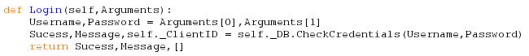
The Login method is used to sign a user in. This takes the Username and password and passeses these to the Database CheckCredentials function which returns the results. The obtained clientID is stored directly in the ClientID attribute.

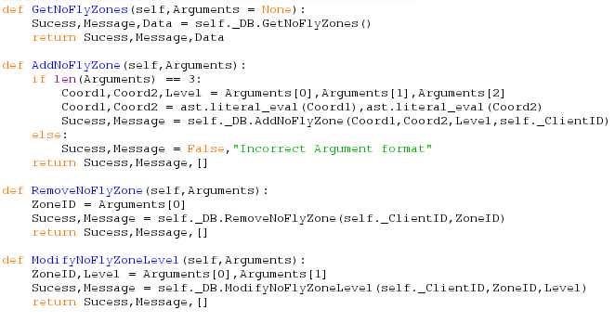
The GetNoFlyZones method is used to obtain all the NoFlyZones from the server database using the DB connection object and relevant method.

The AddNoFlyZone method is used to add a NoFlyZone to the server. The program first tests if the arguments variable has the required number of components, if not an error message is returned. The program then obtains the Coordinates and level from the arguments, ( coord1 → coord 2 spans the NoFlyZone with a level whos cost is equal to the number of other steps the program will consider before using one step in the NoFlyZone) and converts the coordiante strings to coordinate tuples. The program then calls the DB AddNoFlyZone function which returns the relevant information on success etc.

The RemoveNoFlyZone method is used to remove a NoFlyZone identified by the ZoneID passed in the arguments tuple. The program will then call the RemoveNoFlyZone DB function with the clientID to identify the client and the ZoneID to identify the NoFlyZone.

The ModifyNoFlyZoneLevel method is used to change the level of a NoFlyZone identified by the ZoneID to the Level value passed in the arguments. The program uses the DB ModifyNoFlyZoneLevel method to achieve this.

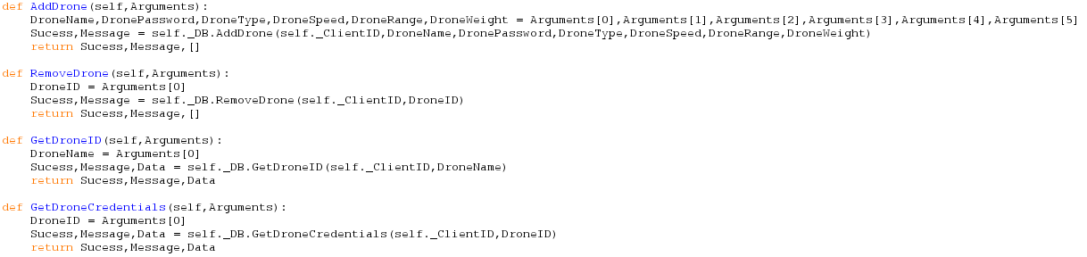
The AddDrone method is used to add a new drone to the database. The parameters are DroneName ( which is unique on a per user basis), DronePassword, DroneType,DroneSpeed, range and weight. These are passed as parameters to the AddDrone method of the database.

The RemoveDrone method is used to remove a given Drone identified by the DroneID value in the arguments variable. The value is passed to the DB RemoveDrone function in order to remove the drone.

The GetDroneID method is used to get the droneID of a drone belonging to the user from a given DroneName. This information is passed to the DB function GetDroneID.

The GetDroneCredentials method is used to obtain the credentials for a given Drone. This may be used if the user has forgotten the Drone's credentials. The program takes the DroneID and executes the GetDroneCredentials method of the database with this DroneID.

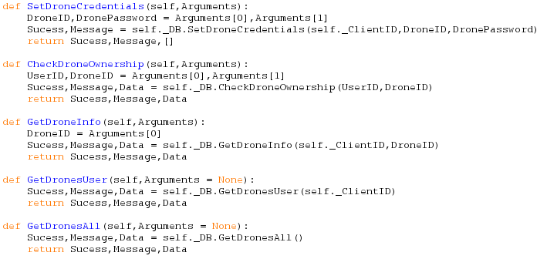
The SetDroneCredentials method is used to set the drone password to a new value. This takes the DroneID and Password from the arguments tuple and passes the information the the SetDroneCredentials method of the database connection.
The CheckDroneOwnership method is used to check if a given UserID owns a given DroneID. The program takes the UserID and DroneID and passes this information to the DB CheckDroneOwnership method of the DB connection.

The GetDroneInfo method is used to obtain details about a given drone. The DroneID is passed to the GetDroneInfo method of the DB connection which processes the data.

The GetDronesUser method is used to obtain details about all the drones belonging to the user. This is obtained using the GetDronesUser method of the DB connection.

The GetDronesAll method is used to obtain details about all the drones belonging to a user who has the FlightVisibility set to 1. This is obtained using the GetDronesAll method of the DB connection.

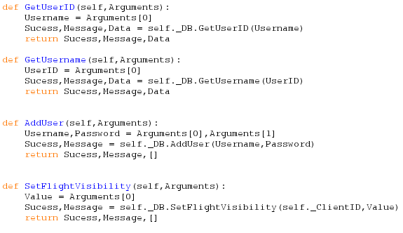
The GetUserID method is used to obtain the UserID of a user with a given Username. The Username is passed onto the GetUserID method of the database which obtains the UserID for that Username.

The GetUsername function is the inverse of the GetUserID method and is used to obtain the Username of a User with a given UserID. The UserID is passed onto the GetUsername method of the database which obtains the Username.

The Add User method is used to add a user to the server. This takes the Username and Password of the new user and passes this information to the AddUser method of the Database connection.

The SetFlightVisibility method is used to set the visibility of the users flights, drones and flight waypoints to the public (1 → visible , 0 → not visible). The SetFlightVisibility method of the database sets the field to that value if acceptable.

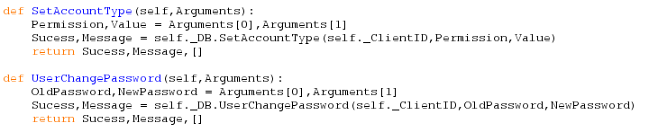
The SetAccountType method is used to change the type of an account ( Set different permissions depending to different values e.g. allowed to create NoFlyZones). This passes the Permission and Value to the to the SetAccountType method of the Database connection which sets the permission if it may do so.

The UserChangePassword method is used by the user to change the password of the user account. This requires the old password to prevent any random person who finds a logged in session from changing the password. The program then passes the new and old passwords to the DB method of UserChangePassword in order to change the password.

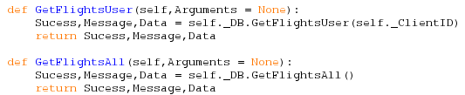
GetFlightsUser is used to obtain the details of all the flights belonging to the user. This takes no user side arguments to the DB GetFlightsUser method which obtains the flight details.

The GetFlightsAll method is used to obtain all the flights which belong to a user which has set their flights to be publicly viewable. The result is obtained from the DB connections GetFlightsAll method.

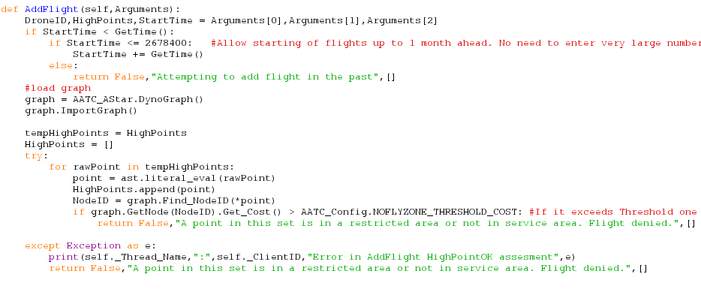
The AddFlight method is used to add a new flight to the flights table. The program takes a DroneID, HighPoints list and StartTime in the arguments variable. The DroneID identifies which drone should be sent, the Highpoints list is a list of waypoint coordinate tuples the flight must pass through to complete the flight and StartTime is the time in seconds at or from which the flight should start.
First the program checks if the StartTime is less than the current time, if so the program checks the size of the difference. If the Time Value is below 2678400 seconds then the program will assume that the flight should take place in that number of seconds, therefore adding the current time to this value. Otherwise the program assumes the flight should be set in the past which is not allowed and therefore a failure message is returned.
The program then creates a grapg and imports the details from disk. The Highpoints are transferred to a seperate list and reset to an empty list. The program will then attempt to convert the highpoints into tuple coordinates rather than string representations of tuple coordinates. The program loops through each coordinate in the TempHighPoints list and converts the string into a tuple, add the new value to the HighPoints list and obtains the NodeID for that coordinate using the graph Find NodeID method and the points coordinates. The program then checks that the NodeID has a cost of less that the threshold defined in AATC_Config.NOFLYZONE_THRESHOLD_COST. This is to ensure that it is not possible to put a Highpoint (waypoint the path must go through) in a NoFlyZone above this level in order to force the server to perform a massive search ( large possible path difference) on the graph as well as allowing the Drone to enter a high level NoFlyZone. Should the test fail and it exceed the limit the program will cancel and return failure. Should an exception occur while this process proceeds ( incorrectly formatted waypoint etc) the try/except statement will handle it and return failure.

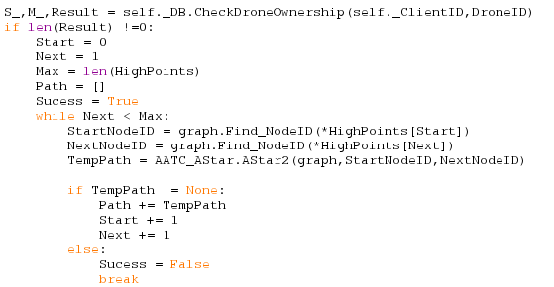
The program will then proceed to identify if the current user owns the drone by using the database connections CheckDroneOwnership method. Should the result show that the user owns the drone the program will continue ( Result has length > 0). The program will then attempt to calculate the path for the drone to fly, start, next and max are set to 0,1 and length of HighPoints respectively. Start is the current Coordinate to start at, Next is the current end coordinate. The Path list, to contain the path, is initialised and Sucess, if the program completed correctly, set to True. The program will then iterate through every pair of start and next, shifting the two wide window along to the end , therefore creating a single whole path connected from end to end. In the loop the program obtains the NodeIDs for the start and next coordinates using the Find_NodeID method of the graph, these are then used by the Astar2 algorithm to find the new section of path. Should the New path contain values ( has sucessfully completed, on failure None is returned) the new path will be appended onto the current path and start and next will be incremented by one, if the search failed the success variable is set to false and the loop is broken.

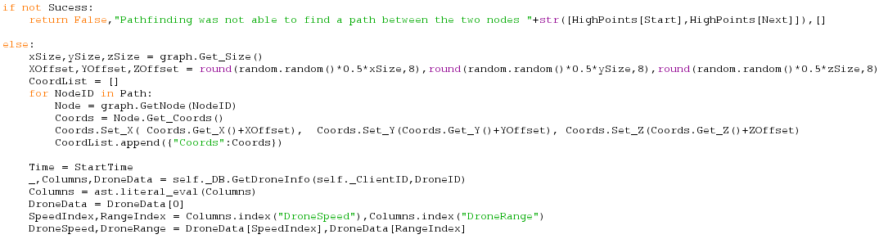
If the search failed thr program will return a failure message. Otherwise the program will continue to process the result of the search. The dimensions of the graph are obtained and used to generate offsets between 0 and half of the size in that dimension. This offset causes each drone to be randomly offset in space from the original node, resulting in the drones being more spread out rather than following a set of line. This reduction in number of drones in a given area by spreading them out reduces the chances of collisions in air and makes it easier for a object avoidance system to function as the drones will most likely be offset noticably.
The program then creates a list of coordinates by looping through each nodeID in the Path calculated , obtaining the nodes coordinates and modifying these by the offset and appending them to the coordinate list in the form of a dictionary.
The program then begins to calculate an ETA for the flight. This involves setting the Time variable to StartTime as well as loading the details of the drone from the database, extracting the DroneSpeed and DroneRange.

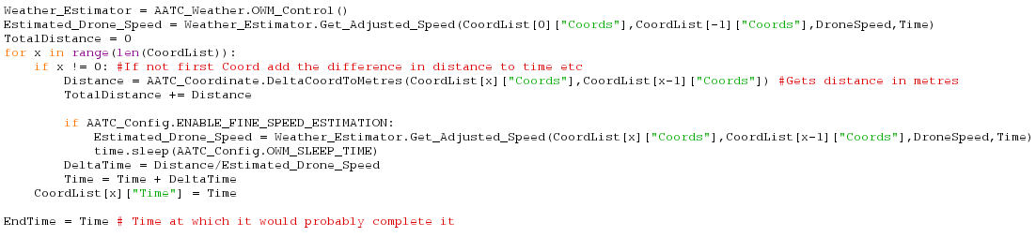
The program then creates an OWM_Control object and uses this to produce an estimate of the speed of the drone from start to end when influenced by the wind at that position.
Then the the program loops through each coordinate, if it is the first coordinate the program will simply set the time to the start time as no distance must be travelled to reach the first waypoint. Otherwise the program will calculate the distance between the last two coordinates and add this value to the total distance variable which keeps track of the total distance of the flight. The program then optionally checks for a more accurate speed using the Weather Estimator again if the relevant flag in the AATC_Config module is set to True. This would allow a more accurate drone speed calculation but would also take up more requests with the OWM service. If the flag is True the new speed is calculated and the program wait a set amount of time to prevent spamming the server with requests. The program will then calculate the difference in time to get to this coordinate and add this to the current time, which is then recorded for that coordinate. Finally the EndTime is set to the last time of the coordinate reached.

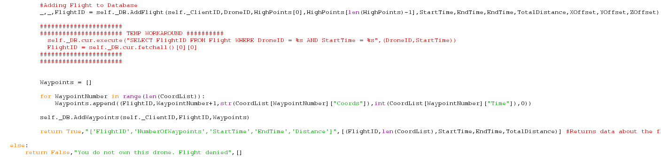
The program then adds the flight to the database with the relevant details, setting the ETA and end time to the EndTime variable contents.
The program then forms a list of tuples containing the details of each coordinate, including the flightID of the flight just added , waypoint number , coordinate, ETA of that waypoint and the irrelevant 0 flag. The list is then used by the database AddWaypoints method to add all the waypoints to the database. Finally the success message is returned.
Should the earlier check for drone ownership fail a relevant failure message will be returned.

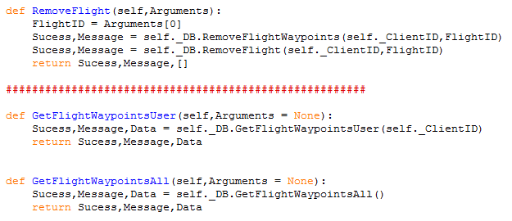
The RemoveFlight method is used to remove a flight with a given flightID. The flight waypoints are removed first using the DB RemoveFlightWaypoints method to ensure that the waypoints will not reference a removed flight causing a foreign key issue. The Flight is then removed using the RemoveFlight method.

The GetFlightWaypointsUser method is used to obtain the details of all the waypoints belonging to the user. This is done by obtaining the details from the DB GetFlightWaypointsUser method.

The GetFlightWaypointsAll method is used to obtain all the details belonging to users who publicly display their flights. The details are obtained using the DB GetFlightWaypointsAll method of the database.

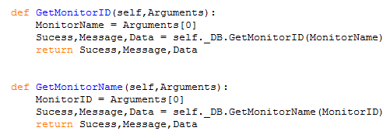
The GetMonitorID method is used to obtain the MonitorID of a monitor from a MonitorName. This is done by using the DB GetMonitorID method.

The GetMonitorName method is used to obtain the MonitorName of a monitor from a given MonitorID using the DB GetMonitorName method to obtain the details.

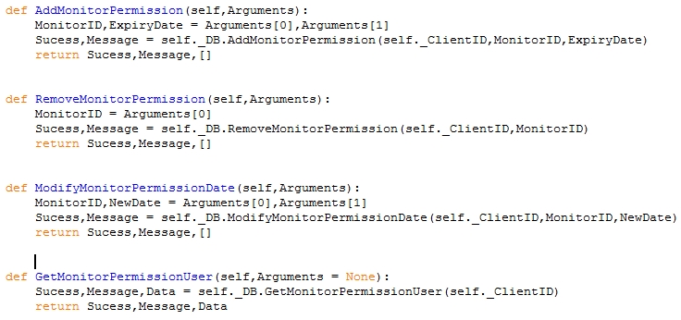
The AddMonitorPermission method is used to add a monitor permission to the server. A Monitor permission allows a monitor to view the user’s drones, flights and flight waypoints even when the user’s flight visibility is 0 up to the expiry date of the permission. This is completed by passing the details to the AddMonitorPermission method of the database connection.

The RemoveMonitorPermission method is used to remove a monitor permission entry from the server for a given monitorID. This is done by passing the relevant information to the RemoveMonitorPermission method of the database connection.

ModifyMonitorPermissionDate is used to alter the expiry date of a monitor permission without the need to remove and readd the permission. This allows the expiry date to be altered at a later stage e.g. to extend the permission. This is done by passing the new date and relevant data to the DB ModifyMonitorPermissionDate method.

The GetMonitorPermissionUser method is used to obtain all the monitor permissions belonging to the user. This is accomplished by using the DB GetMonitorPermissionsUser method of the database interface.

BotConnection
The bot connection object is used in the execution of commands for the telegram bot. The class inherits from the UserConnection class and overrides some of the functions in order to be compatible with the telegram bot User system. This involves using the database to store which chat_id is signed into which UserID, modifying the send method and the way the program acts in the main method.
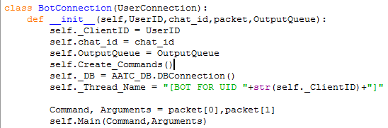
The BotConnection object takes the UserID, chat_id, packet and OutputQueue items as arguments. The UserID is the current UserID for the given chat_id. The chat_id references which chat the program is currently working for. The packet item consists of a (command,(arg1,arg2,arg3…)) tuple which the program should execute. The OutputQueue is used to send back messages to the main process to be sent to the relevant chats.
The program stores each of these values in attributes except for packet. The program creates a DB connection object and stores it in an attribute as well as the running the Create_Commands method and sets the thread name to a value displaying that it is a bot. The command and arguments are extracted from the packet and used to execute the main method of the class.

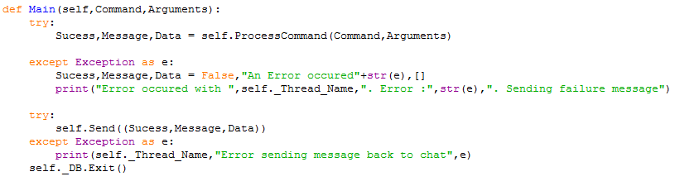
The main method is used to execute the packet with the set attributes. This is used instead of the connection loop method in the parent class as the program should only execute once rather than continue in a loop. The program takes the command and arguments of the packet, processes the command using the ProcessCommand command , catching the exception in the try except statement if needed. The program will then use the modified Send method to return the response to the main bot thread , catching an exception if needed, and finally will exit after closing the database connection object.

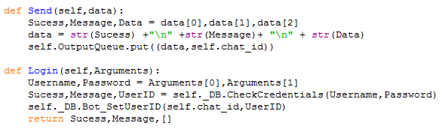
The Send method of the parent class is overridden so that the program sends the response of any processing to the main bot thread so that it may be sent back to the chat using the telegram API. The success , message and data variables are obtained, converted to string and placed separated by newline characters in a single string. This string along with the chat_id to send the message back to is sent using the Output queue object back to the main bot thread.

The login method is also modified as there is no longer a persistent thread per client, instead the chat_id : UserID key pairs are saved in a database , therefore keeping track of which chats are logged into which UserIDs. Therefore the login method no longer sets the ClientID attribute to a value, instead the program modifies the record in the database on login.

MonitorConnection
The MonitorConnection interface is used to communicate with a monitor client. A Monitor can be thought of as a weaker User, it can only observe and not interact and is only able to see what is made publicly available and what users give permission for it to see. A Monitor most likely will be used to produce a display of the current positions of each entity i.e. as a web page display or persistent display setup.

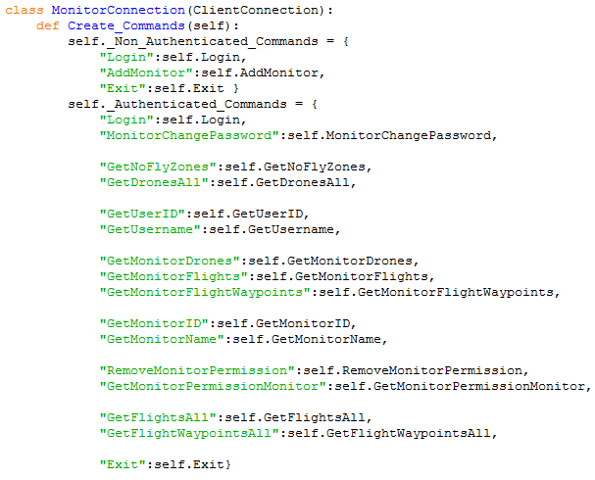
The class inherits from the Client connection class. The class first defines the Create_Commands method which defines the authenticated and non authenticated commands, setting which commands are available to which users and which methods these should then run.

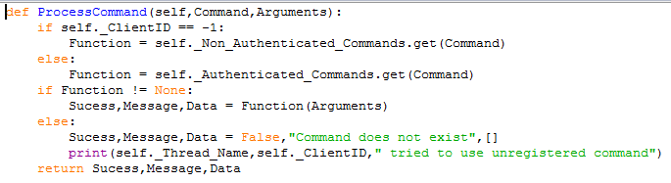
The ProcessCommand method is used to execute the relevant command using the command and arguments provided as arguments. Should the monitor not yet be signed in the function is extracted from the Non_Authenticated_Commands dictionary , otherwise the authenticated commands dictionary is used. As the get function returns None if the key is not in the dictionary the function will be None if the command does not exist. Therefore the program will execute the function if it is not None and return the message that the command does not exist if it is None. Finally Success, Message and data variables obtained from the function or the alternative are returned.

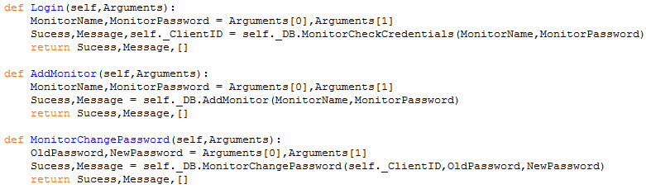
The Login method is used to authenticate the monitor. This is done by passing the login details to the DB method MonitorCheckCredentials.

The AddMonitor method is used to create a new monitor account. This is done by passing the details (Name and password) of a new monitor account to the DB AddMonitor method.

The MonitorChangePassword method is used to change the password of a monitor (i.e. correct security practices). This takes the New and old password ( old password required to ensure that an already logged in session cannot be used to alter the password, client must know old password) and passes the information to the MonitorChangePassword method of the DB connection.

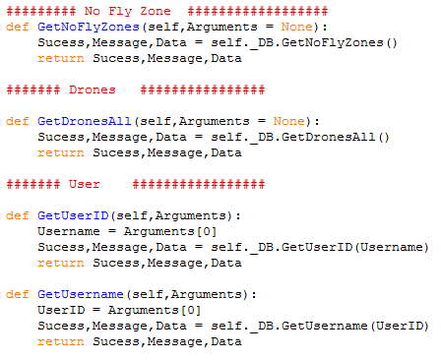
The GetNoFlyZones method is used to obtain the details of all of the NoFlyZones on the server. The details are obtained using the DB GetNoFlyZones method.

The GetDronesAll method is used to obtain the details of all the publicly available drones, those whose owner has the FlightVisibility enabled. The details are obtained using the DB GetDronesAll method.

The GetUserID method is used to obtain the UserID of a user whose Username is known. The Username is passed to the DB GetUserID method and the username is obtained.

The GetUsername method is used to obtain the username of a known UserID. This UserID is passed to the GetUsername method of the DB connection which obtains the information.

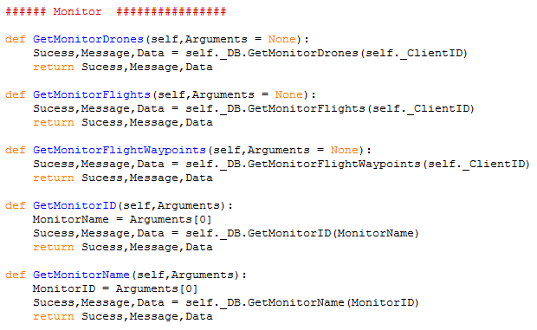
The GetMonitorDrones method is used to obtain the details of all the drones to which the monitor has access to due to a monitor permission. The information is obtained using the DB GetMonitorDrones method.

The GetMonitorFlights method is used to obtain the details of all the flights to which the monitor has access to due to a monitor permission. The information is obtained using the DB GetMonitorFlights method.

FlightWaypoints The information is obtained using the DB GetMonitorFlightWaypoints method.

The GetMonitorID method is used to obtain the MonitorID of a monitor using a monitor name. The MonitorID is obtained using the DB GetMonitorID method.

The GetMonitorName method is used to obtain the MonitorName of a monitor using a MonitorID. The MonitorName is obtained using the DB GetMonitorName method.

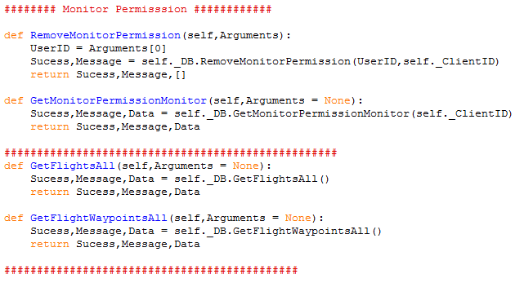
The RemoveMonitorPermission method is used by a monitor to remove a monitor permission that it no longer wants, identified by the UserID of the permission. This permission is then removed using the DB RemoveMonitorPermission method.

The GetMonitorPermissionMonitor method is used by the monitor to obtain the current monitor permissions for that monitor using the dB GetMonitorPermissionMonitor method.

The GetFlightsAll method is used to obtain all publicly available flights on the server, those whose owner has enabled their flights, drones and waypoints to be publicly available. The details are obtained using the DB GetFlightsAll method.

The Get FlightWaypointsAll method is used to obtain all publicly available flight waypoints on the server, those whose owner has enabled their flights, drones and waypoints to be publicly available. The details are obtained using the DB GetFlightWaypointsAll method.

DroneConnection
The DroneConnection object allows the server to communicate with drone clients. The drone clients in this project are only simulations and are run in a seperate python instance. Drones perform the flights set to them by the Users who own them by checking for flights, obtaining the flight information, follow the flight waypoints and mark the flight as complete in a loop.

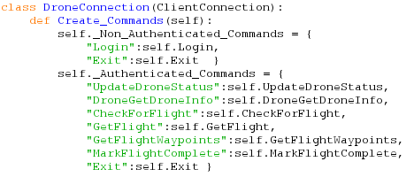
The drone connection class inherits from the client connection class. The program uses the create_commands method to define the allowed commands if the drones are logged in or not.

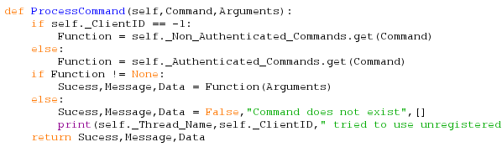
The ProcessCommand method is used to execute the relevant command using the command and arguments provided as arguments. Should the drone not yet be signed in the function is extracted from the Non_Authenticated_Commands dictionary , otherwise the authenticated commands dictionary is used. As the get function returns None if the key is not in the dictionary the function will be None if the command does not exist. Therefore the program will execute the function if it is not None and return the message that the command does not exist if it is None. Finally Success, Message and data variables obtained from the function or the alternative are returned.

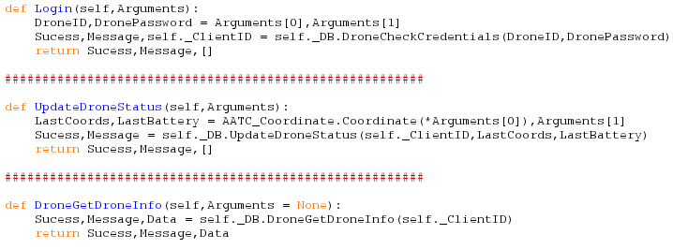
The Login method is used to let the drone sign in, allowing the server to identify which drone has connected. This is done with the DroneID and DronePassword ( no drone name ) and the DroneCheckCredentials method of the database.

The UpdateDroneStatus method is used to allow the drone to update it's status ( Battery level and current coordinates) on the server. This is achieved using the UpdateDroneStatus method of the DB connection.

The DroneGetDroneInfo method is used to allow the drone to obtain information about itself. This is mainly used by the simulation program to better simulate the drone, however it could be used to control the speed and range of the drone automatically (i.e. set the drone to fly slower than the maximum possible speed).

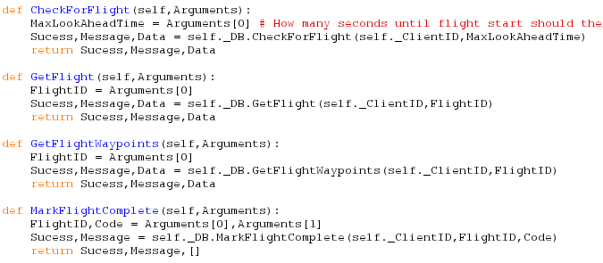
The Check for flight method is used by the drone to check if a flight is available for the drone. The Drone passes the MaxLookAheadTime parameter which governs how far into the future the drone may select a flight from in seconds ( i.e. starting a flight 18000 seconds early because the drone is not busy). The request will pass back the next flight available.

The GetFlight method is used to obtain all the details about a given flightID in order to complete the flight. This is done using the GetFlightWaypoints method of the DB connection.

The GetFlightWaypoints method is used to obtain all the waypoints for a given flightID. This is so the drone may follow these waypoints to take the correct path to the target. These details are obtained using the DB GetFlightWaypoints method.

The MarkFlightComplete method is used to mark the flight as complete. This is done at the end of the flight to show the flight is complete. The Code flag can be used to signal if it sucessfully completed or not.

Cleaner
The cleaner procedure is used to remove old entries from the database. The program continously loops removing old permissions, flights and flight waypoints from the database to prevent the aggregation of useless entries and to ensure the monitor permissions are removed in a timely manner ( monitor permissions are seen as valid so long they exist, even if they have expired, therefore the cleaner must remove the invalid permissions when possible). The removeal of old flights and waypoints prevents the database growing too quickly and causing the program to require more time to complete a query.

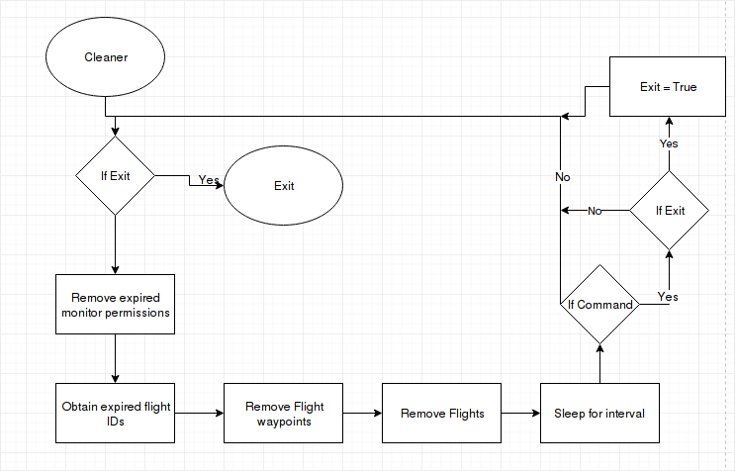

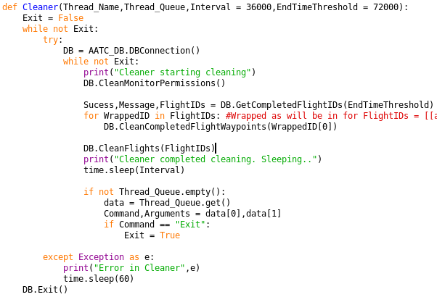
The procedure takes 4 arguments of which two are optional. The Thread_Name parameter is used to define the name under which the cleaner will be called/ the name of the thread it belongs to. The Thread_Queue parameter contains a queue from which the cleaner obtains it’s commands i.e. to exit. The Interval parameter sets the time between cleans in seconds. The EndTimeThreshold is the age in seconds which the end time of a flight must be older than and completed to be seen as removeable and for flights which are not marked as complete this value must be 3 times greater ( must be 3 times older in order to be seen as removeable).
The program first sets the boolean variable Exit to false. The program will then continously loop until the Exit value is set to True. The program will then attempt to execute the section inside the try/except statement , should an exception occur the program will catch it and sleep for 60 seconds ( to prevent rapidly failing in a loop). The program will first create a connection to the database using the DBConnection object, then looping continously until told to exit. The inner loop first removes all expired permissions and then obtains a list of all the removable FlightIDs. This list is used to remove all flight waypoints with that flightID by looping through every ID in the list. The program then remove the flights for these flightIDs , removing the flights after the flight waypoints is required otherwise there would be a lack of a flightID which the forigen key of the flight waypoints would reference, breaking a constraint of the database and causing an error.
The procedure proceeds with sleeping for the required interval using the time.sleep procedure. Then the Thread_Queue is checked for instructions , if the instruction is the exit command the Exit variable will be set to True.
Once the cleaner has exited the loops the database connection object will be closed and the cleaner will stop.

